

**Stock Portfolio Management System**

**Software Requirement Specification (SRS) Document**

**Sprint Implementation**

**Project Timeline: 20.10.2022 to 28.10.2022**

**INDEX**

1. Introduction

1.1 Purpose -------------------------------------------------- 4

1.2 Intended audience -------------------------------------------------- 4

1.3 Intended use -------------------------------------------------- 4

1.4 Scope -------------------------------------------------- 4

2. Overall description -------------------------------------------------- 5

2.1 Assumptions and dependency -------------------------------------------------- 5

3. System feature and requirements -------------------------------------------------- 5

3.1 Functionality -------------------------------------------------- 5

3.1.1 Print Queue —----------------------------------------------- 5

3.1.2 Enqueue -------------------------------------------------- 5

3.1.3 Dequeue -------------------------------------------------- 5

3.2 System requirement -------------------------------------------------- 6

3.2.1 Tools to be used -------------------------------------------------- 6

3.3 System feature ------------------------------------------------ 6

4. Dataflow Diagram

4.1 DFD level 0 ------------------------------------------------ 8

4.2 DFD level 1 ------------------------------------------------ 9

### **1.** **Introduction: -**

The stock portfolio management system is the portfolio for the investments and shares of companies which can manage the investment easily for our convenience by adding the investments with the shares and obtaining the profit and loss by the investments.

**1.1 Purpose:** **-**The stock companies' data will be added to the portfolio where stock details average market price, price (P), and shares. User can add the amount of investment to the current market price of the shares and maintain the profit and loss for the stock investments.

**1.2 Intended** **Audience: -**This document is intended to be read by Admin.

**1.3 Intended Use: -**

* Development Team
* Maintenance Team
* Clients

Since this is a general-Purpose Software, anyone can access it.

**1.4 Scope: -**This project aims to create the maintenance of a Stock investment management system, which takes the stock details, adds an amount of investment to the database, and maintains the profit/loss of the stock investment which it is easy to maintain the stock investments and shares to the required stock companies.

**2. Overall Description: -**

The stock portfolio management system is the portfolio for the investments and shares of companies which can manage the investment easily for our convenient by adding the investments with the shares and obtaining the profit and loss by the investments. The stock portfolio management system is a project that helps us understand the basic concepts of functions, file handling, and data structure. The stock companies' data will be added to the portfolio where stock details average market price, price (P), and shares. User can add the amount of investment to the current market price of the shares and can maintain the profit and loss for the stock investments.

**2.1 Assumptions and Dependency: -**

* System should have Ubuntu Linux installed.
* · System should have either 4GB or more RAM.
* The service is used preferably on a desktop or laptop.

**3.System Features and Requirements: -**

**3.1 Functionality: -**

**3.1.1 BG_01-> Print Queue: This function is used to print the data which is present the data in the excel sheet**

**3.1.2 BG_02-> Enqueue**: This function is used to add the stocks in the data.

**3.1.3 BG_03->** **Dequeue:**  This function is used to remove the stock from data.

**3.2 System Requirements: -**

### **3.2.1. Tools to be used:**

. Shell scripting

* C File Handling
* C Language
* System Programming

### **3.3 System Features: -**

### Supportability:The system is easy to use.

* Design Constraints: The system is built using only C language.
* Usability:Stock Management software is used by traders and investments managers to monitor and optimize performance of their own and their clients’ investments. This portfolio can include investment securities. It minimizes the risks involved in investing and increases the chance of making profits.
* Reliability & Availability**:** The system is available 24/7 that is whenever the user would like to use the system, they can use it up to its functionalities.

### Performance: The system will work on the user’s terminal**.**

**4. Dataflow Diagram:**

**4.1 DFD Level 0-**

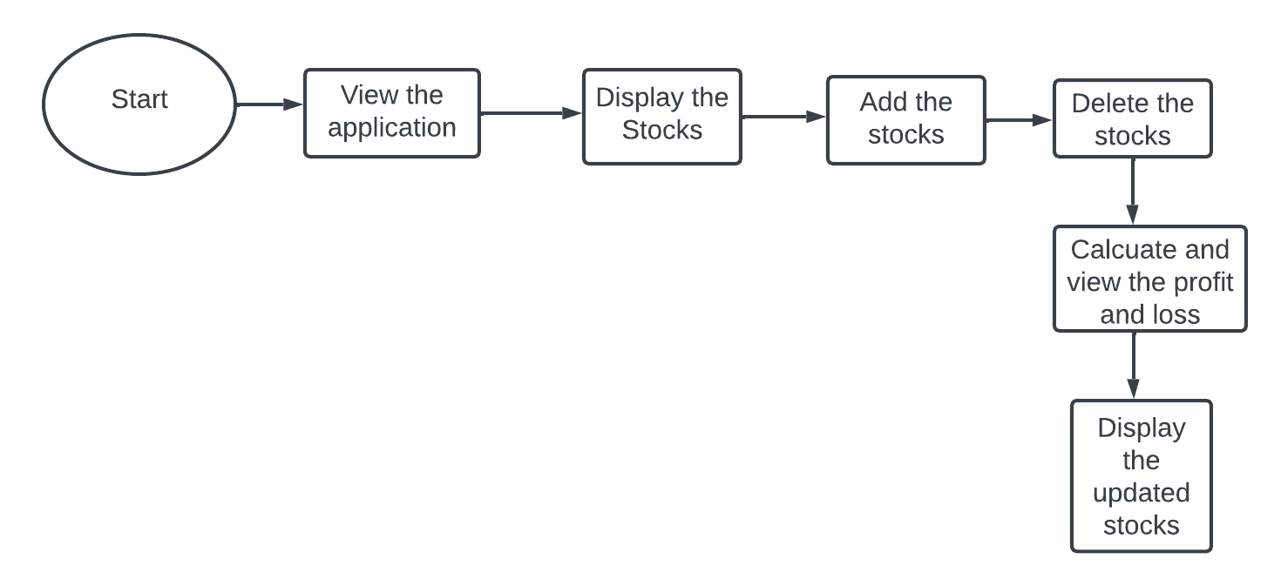

**DFD Level -1**

